THE ROUTE TO ANALOGUE RANDOMNESS

Dr Jack Tait Abergavenny Wales UK 2022

INTODUCING THE AUTHOR

Paul Brown and Dr Nick Lambert are eminent generative artists who have consented to write introductions to the author. Paul is Honorary Visiting Professor, Sussex University ,UK and Dr Nick Lambert is President of the Computer Art Society and Director of Operations,
VISTA Project, Faculty of Computing, Engineering and Science University of South Wales UK

Paul Brown Jack Tait

Two British pioneers who created electro-mechanical drawing machines emerged in the 1960s, they both lived in Manchester but never met. Desmond Paul Henry bought analogue war-surplus bombsight computers and modified them to make complex drawings. Jack Tait was a photographer who had developed precision engineering skills that he used to make his super wide angle photographic cameras, skills he then applied to the design and creation of sophisticated programmable analogue drawing systems. At that time, he was the founding head of the Dept. of Photography at Manchester College of Art & Design where I was an undergraduate painting student. Our paths crossed occasionally when I used his photo labs. We never got to know each other and more than three decades would pass before we met again via the auspices of the Computer Arts Society (CAS). Alan Sutcliffe, CAS co-founder and editor of their publication PAGE, dedicated an issue to Jack’s machines and drawings (1). He was keen to pursue a PhD, documenting and contextualising his work and I invited him to visit Sussex University where I was a visiting professor and artist-in-residence in the Informatics Dept. We met with Phil Husbands, who led the Informatics research programme, and he advised Jack to find an opportunity for a practice-based Ph D, something that Sussex couldn’t offer at that time. Jack returned to Manchester where the Art College had become a faculty of the Manchester Metropolitan University.

In 2011 I was pleased to be invited to be external examiner for his PhD. Jack’s work was exceptional; he described his working methodologies and the works relationship to visual cognition and aesthetics. Like several of his contemporaries who emerged from the constructivist, concrete and systems art traditions that dominated the middle decades of the 20th century, Jack creates his machines to bypass issues like self-expression and focus instead on the more formal aspects of the artwork. His systems are designed to address specific issues like randomness, chance and the relativity of line and shape. Recent work also explores psychophysical aspects like, for example, comparisons of the subjective interpretation of his drawings by different observers. The mechanical constraints together with the programmable, parametric control enables a degree of fine tuning, creation, examination and analysis that would otherwise be difficult if not impossible. His machines now include optical heads for photographic recording that also enable the automatic generation of colour and produce work at a greater scale than was previously possible.

By pursuing this rigorous evolution of his image-making systems Jack has carved out a unique place for himself in the field of the generative and computational arts. In 2013 London’s Science Museum recognised his contribution by acquiring seven of his machines with four programmers for their permanent collection together with videos documenting their maintenance and use as well as many of the drawings they had produced.

Paul Brown
Ocean Shores, Australia
April 2022

- Taitographs – drawings done by machine, PAGE 65, bulletin of the Computer Arts Society, Autumn 2007. https://computer-arts-society.com/uploads/page-65.pdf - accessed 10 April 2022

Dr Nick Lambert - Jack Tait’s Taitographs and controlled linear motion

Since the 1950s, Jack Tait has worked as a photographer, designer and educator, with a considerable output of work in each of these fields. Having established the photographic schools at Derby and Manchester Colleges of Art, he was also head of department at Newport College of Art, where he pioneered the use of computers in graphics education during the mid-1980s.

Whilst pursuing his other interests, Tait has maintained a consistent commitment to the development of a mechanical approach to producing and understanding aspects of art, leading to the work for which he was awarded a PhD by Manchester Metropolitan University in 2011. Tait subsequently compiled his extensive art experiments into a single text, Art by Machine, that details his approach, results and theories on the nature of machine-produced art; and the forms he calls “Taitographs” that emerge from his mechanical devices.

With a background strongly informed by Systems Art and process drawing – Kenneth Martin’s work on chance and order is referenced – Tait is particularly concerned with the way in which chance and order can create aesthetically pleasing drawings. There is some discussion of the way in which aesthetic choices in terms of the construction and setup of the linkages and switches in the Taitograph machines affects the outcomes; and it is clear that Tait’s intimate knowledge of his systems enables him to suggest the general outcomes, but not the specific results, of each system.

This is not to say that he determines the output as such, but rather sets up the conditions by which a particular outcome is made more likely. Obviously certain Taitographs will only produce results within a particular range of outcomes, but Tait insists that his machines transcend the use of “tools” in art, because they are not merely extensions of the artist’s hand and eye; instead, some decision making and therefore control are delegated to them.

For this reason, Tait’s work goes some way beyond the Lissajous-type figures that are found in earlier drawing machine work and moves towards timing mechanisms and ways of stopping and reversing the direction of the pen; and later mechanisms for varying the amplitude and lifting the pen as well. His NSEW machines, which even include rotating pen selectors holding different line weights and colours, produce more “gesture-like” drawings (in Tait’s terminology) that have a calligraphic freedom compared to the tight curves of his earlier systems. This reflects Tait’s insistence that the wider range of variables at work in the NSEW systems, some of which are quite subtle, show how pseudo-randomness can be deployed in making artwork.

Perhaps the best expression of the incorporation of both deterministic and randomised elements is found in the images produced using a light pen. By substituting this for a physical pen, and using a DSLR camera and photographic enlarger to capture the images (a cunning fusion of old and new photographic technologies), Tait produces what I think are his most compelling images. One can see a suggestion of the Constructivist origins of his thinking on process in art: the light drawings seem to pick up where Moholy-Nagy and Man Ray left off with their “photograms”. Tait has arrived at this form from a very different direction to these pioneers, but the idea of a non-objective photograph produced using purely mechanical means has a very interesting heritage of which he is fully aware.

THE ROUTE TO ANALOGUE RANDOMNESS

Abstract

The route to programmable analogue drawing is set out as a journey where the destination, defined by current work, is the exploration of Randomness ^{1,2,3}, Chaos ² and Subjectivity ^{4,5}. Points along the journey represent general and specific meanings and places encountered show how the work arose. The machines and their drawings present a variety of effects. The analogue route is circuitous, often arbitrary, each image a signpost flagging progress. Influences of other practitioners serve as reference points along the way.

The ‘means of transport’ is analogue not digital. The latter might resemble a ‘motorway with a specific destination’. Analogue ‘potters along country lanes’ with a vague end point. Analogue artist's 'build the vehicle, make the fuel and at times abandon steering control'. Digital artists employ ‘ready-made vehicles steered by algorithms usually with a specific destination.

Generative work is mainly digital. The choice of analogue is justified as it is likely to produce significant differences, where images are judged on merit and meaning.

The selection method is influenced by a Modernist approach, felt to be more appropriate to the author’s work than a post-Modernist stance. The headings Make, Develop, Select and Display, create a context for the review. Criteria are addressed where appropriate but the element of surprise at the results, is fundamental, providing constant motivation.

Randomness, Chaos and Subjectivity is the destination. However, an added benefit of recent work indicates the potential for gaining insights into how art might work.

Curiosity is the mainspring which drives all activity.

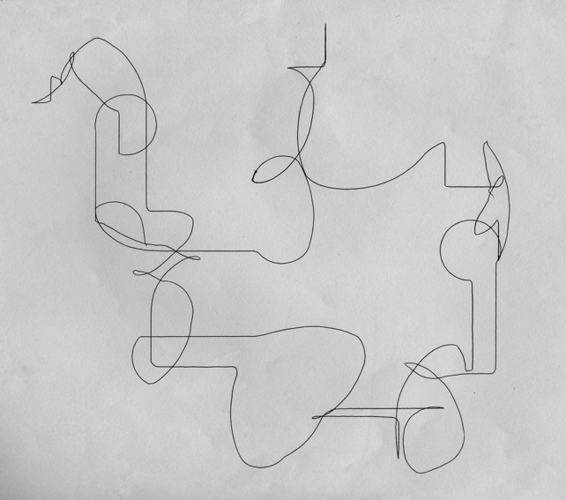
START POINT

Fig 1 In keeping with the stated theme the paper starts with a drawing which both typifies current work and shows hommage to a major influence Paul Klee ⁶.

Curation
This is central to most art forms and applies to Machine Art. Perhaps it may be defined further as Make, Develop, Select and Display. These divisors create a context into which all the images may be examined. But before dealing with current programmable drawing machines it may be helpful to examine the way the author’s work ⁷ was influenced by art movements current at the time. The examples are initially in photographic form leading onto generative drawings later. The detail on influences is offered from the unusual perspective of an analogue artist where most of the practitioners use digital methods. These differences are interesting and are discussed in Conclusions.

Influences leading to analogue generative art. 1961- 1975
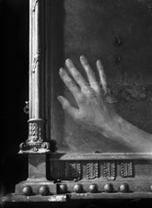
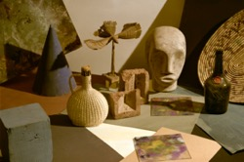
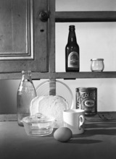
In the beginning most artists are inspired by the work of others. The author’s influences began in the 50’s by an immersion in the Modernist movement in particular the Bauhaus ⁸. The School of Photography, in Guildford College of Art, ⁹ was created by Ifor and Joy Thomas and was the most famous venue in the UK for having its curriculum wholly based on Bauhaus principles. Whilst the author’s output was photographic, it drew inspiration from Modernist painters Kandinsky ¹⁰, Miro ¹¹ and Bauhaus artists Paul Klee ^{6,} Moholy-Nagy ⁸ and Man Ray ⁸. This aspect of the author’s work was recognised by the school and resulted the award for the year’s best work in both year one and year three which was unprecedented.

Figs 2, 3 and 4 Modernist and Bauhaus inspired images from Guildford 1955-8

Joy Thomas’s teaching inspired a generative stance. A harmonograph rig in the studio swung a punctured tin of Lyles Golden Syrup, the dribbles of treacle on paper were filmed as a 16mm movie. In the early 60’s this led to a Meccano drawing machine, Fig 16 prior to Jasia Rheichardt’s Cybernetic Serendipity exhibition in 1968 ¹². I was very sorry to have missed being in this event.
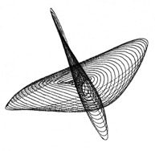

Figs 5-7 Three early Meccano machine drawings from the 60’S
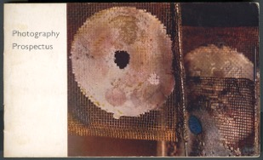
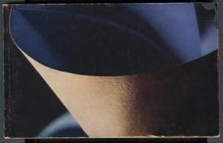
In 1961 the author started a department of photography at Derby ¹³, where two A5 prospectuses showed Modernist influences in their colour covers. At that time no other photography department in the UK (except for Guildford) published a prospectus which included photographs.
Fig 8-9 A5 prospectus covers

From Derby, a Kodak Colour Scholarship ¹⁴ in 1964 led to a 3 month stay in Rochester USA where the influence of American artists was emerging on the international scene. The work produced there again was strongly influenced by the current movement in painting. See Figs 10 & 11.

Two images below were influenced by New York painters, Fig 10 was the cover picture for the Kodak 1966 calendar which the author designed and produced. This was collected by the Kodak Museum some years later.
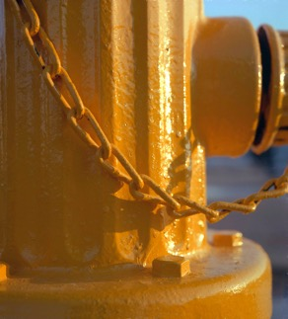
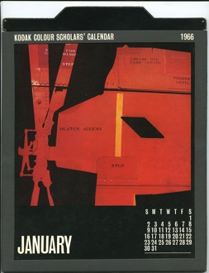

Fig 10 Hard edge abstract image Fig 11 Painterly image of Street furniture
In the 70’s the author started a photography school at Manchester Polytechnic ¹⁵ in 1965, possibly the largest and the best equipped in Europe with a budget of £100,000 for equipment and 10,000 sq feet of studio and darkroom space. During this time more drawing machines were made (see Making below) and the images used in a book ‘Beyond Photography’¹⁶ It explored photographic images in fine print some of which were generated by drawing machine Fig13.

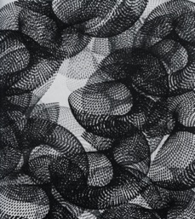
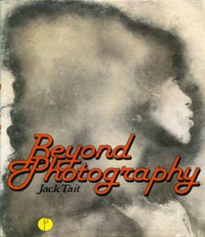

Fig 12 Cover of book on Fine print Fig 13 Machine drawn image multiple print

Finally, drawings with light. Figs 14 &15 also began with the machine shown in Fig 18 below and these images mark the point that the author was fully committed to generative Art, and it leads onto the beginning of the 50 plus machines which have been part of the long research process alluded to above. In their creation there was already a large proportion of randomness present. The detailed programming aspect was only being developed at this stage.
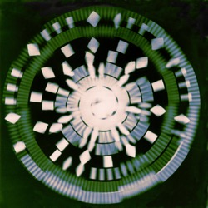

Fig 14/15 Machine drawings (see machine in Fig 18) with light onto 4x5 transparency film
Making
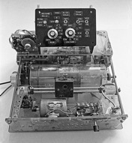
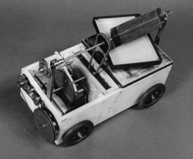
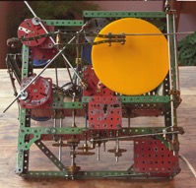
With the analogue route the first step, following the nascent idea, involves making a machine to satisfy curiosity about moving a pen or light source and observe the results. The method adopted starts in the workshop with the materials and allows the machine to emerge organically rather than make prior drawings. This is analogous to a painter beginning with a blank canvas, making the first mark and then seeing how the image develops.

Fig 16 Meccano machine Fig 17 Drum plotter Fig 18 colour film moving table

Above are machines from the 70’s, Meccano plotter with turntable Fig 16, first programmable drum plotter Fig 17 and a basic light machine ‘film mover’ which ‘drew’ onto 4x5 transparency film Fig 18. Construction quality improved when Meccano was abandoned in the 90’s as it was insufficiently accurate.

Following a long career gap, in 1980 the author was offered a Ph.D position in the Royal College of Art ¹⁷ on the topic ‘The use of a computer to help understand how art works’. This was promising but proved premature. At that time, it was difficult to find supervisors with art backgrounds who understood computers and computer scientists who understood art. The project was abandoned; the decision was compounded by the pressure of a new job as Head of Graphic Design at Gwent College of Higher Education ¹⁸ where the task was to introduce new technology; Apple computers in 1982 when computers were rare in art colleges.

In 1981 the college bought the author a 1969 Hewlett Packhard 9125A calculator and X:Y plotter programmed in a base 8 language ¹⁹. Generative images were made, paying hommage to Kandinsky ¹⁰ and Kenneth Martin ^{20.}

The machine had only 4 K of memory, and drawings took hours to complete. Eventually attention switched to analogue machines in the 90’s. The line drawings had colour added in Adobe Photoshop. However the short lived computer programming stage did lead to programmable analogue machines.

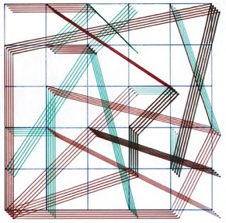
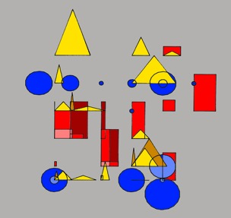

Fig 19 Hommage to Kandinsky Fig 20 Hommage to Kenneth Martin

Fig 21 Random path circles Fig 22 Sinewaves

The next step forward in making many well engineered drawing machines began in the late 80s / 90s and continued until 2007 when I began a Ph.D study at MIRIAD - Manchester Institute of Research in Art and Design ^{21,22} completed in 2011. From this study, seven machines, four programmers’, eleven instruction movies and drawings were collected by the London Science Museum ²³.

Since then more have been built ranging from Lyssajous figure generators, X:Y plotters, Turntable machines, and Sine wave generators. Recent machines and programmes have been directed towards studying Randomness and Chaos together with several papers published on this topic. There is insufficient space to show all the machines, 50+ in all, but a few current ones are included below with two typical programmers including the latest Randomiser.

RANDOMNESS MACHINES
Existing machines are being used or modified to enable specialisation on randomness, chaos and subjectivity. Four machines identified above have been used to forward this initiative; each is shown alongside drawings produced.

The X:Y plotters may also be used to draw with light onto a digital camera making a fifth avenue of exploration. So far the X:Y plotters have made the best inroads to the randomness study but other machines have contributed a variety of graphic and photographic results which extend the scope.

HHM Hommage to Henry Machine
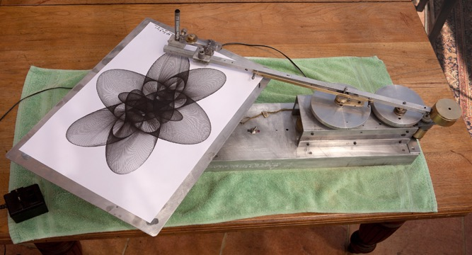
(reverse engineered Paul Desmond Henry machine ²⁴ from the 70's, see below)
Fig 23 The first version of the HHM machine showing a close line to line drawing in progress.
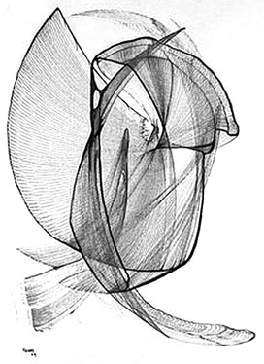

Fig 24 one of the first drawings Fig 25 copy of a Paul Desmond drawing
used by permission of Elaine O’Hanrahan

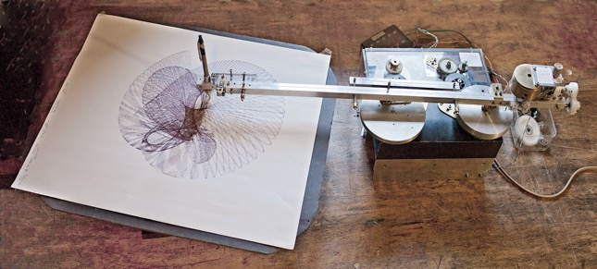
The recent version of the Lyssajous figure machines in Fig 26 stemmed from a project working with Elaine O Hanrahan, Paul Desmond Henry's daughter, to reverse engineer his machine from the 70's which was based on the WW2 Sperry Bomb sight computer ²⁵. No instructions were available and the original parts were damaged. The analysis was successful on the first attempt, so much so that with modifications it led to the authors best machine of this type ever built.
Fig 26 The current HHM machine
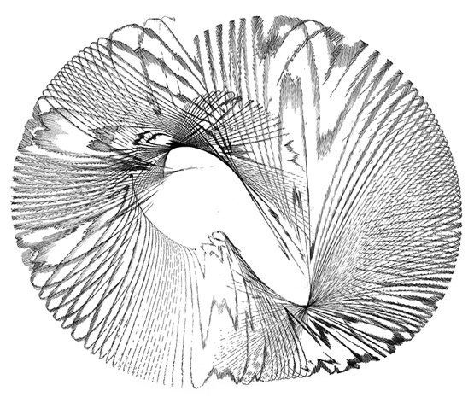
The first machine in Fig 23 had separate D.C. motors for each axis and the X:Y ratio relied upon the motor’s speeds running to very close tolerances to generate the phase shift as was the case with the Bombsight machines. A potentiometer in circuit between the X and Y motors allowed fine adjustments to the X:Y speed ratio. The propensity for D.C. motors to 'hunt' creates variations in the line to line character which typified the outputs. Figs 24 &25

Fig 27 Later drawing, showing character which encouraged research into random effects

Adding pen lift, elliptical table, and differential control of the X:Y axis ratio improved scope allowing research into randomness and chaos. Fig 26 above. The differential meant that the ratio between X and Y could be set to extremely fine limits of 1:1.002 which gave a line to line spacing of one line width. This accuracy meant that very small shifts in phase relationships related to randomness and secondary out of phase effects became very evident Fig 27.

X:Y PLOTTER RIGS (named NSEW - North, South, East, West)
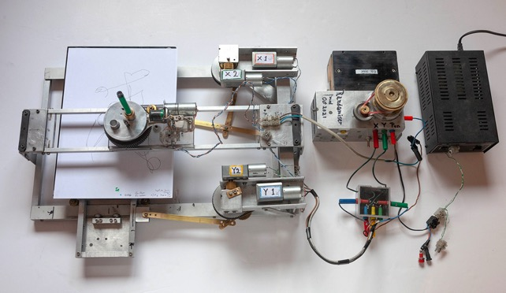
More versions of this type of machine have been made than any other; all depend on external programmer control in the form of sequential timers. Recent improvements in both have facilitated investigation of random characteristics. A significant addition was made when the X and Y axes were driven by sun and planet systems. This meant that four motors could be used, two for each axis allowing increased line characteristics, also making randomness and chaos effects easier to study. Two versions of the sun and planet drives exist, one chain driven, giving a linear output and the other cam driven, which is non-linear. Both have been used in the most recent randomness work.
Fig 28 The most recent X:Y rig with pen bridge, Randomiser and power supply used to create the drawings below. The same rig can be converted to allow light drawings.

Figs 29-32 are selected from a large set of drawings exploring the coupling of X, and Y axes with circles made by a pen rotator. The use of sun and planet system generates complex curved line characteristics.
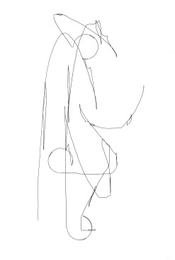
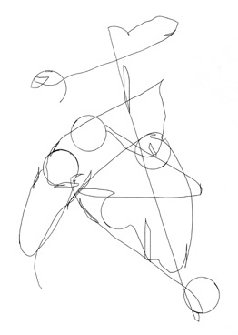
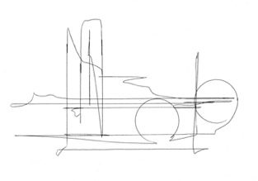
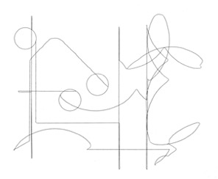
Fig 29 Fig 30

Fig 31 Fig 32

Simple X and Y axes would only generate straight lines; vertical, horizontal and diagonal. These graphic elements were chosen as the minimum group where the drawn lines could take a random input towards the edge of graphic chaos. In addition it might provide images where the viewer's subjective responses to a chosen set of 10 could be examined. The Randomiser programmer was used for the drawings.

TURNTABLE MACHINES with optional linear table

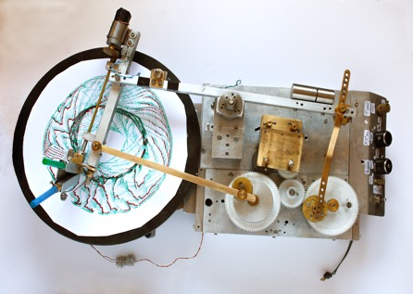
Turntable machines have provided drawings with random aspects but the machine shown below was specifically designed to explore them in circular images. The linkages were quite different from previous designs and a two-pen holder was added with pen lift facility. With both the Lyssajous figure machine and the latest turntable machine two special linear platforms have been made for them to allow continuous linear drawings (as a substitute for a circular turntable) to extend the character to see if the chaotic images were more likely in this form.
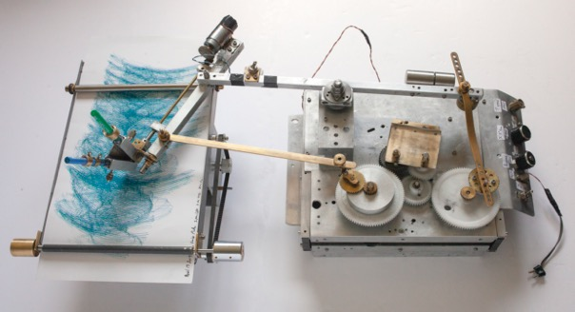
Fig 33 Special turntable machine with different linkages to previous machines
Fig 34 Special turntable machine with alternative linear table
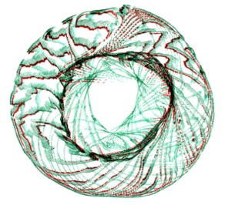
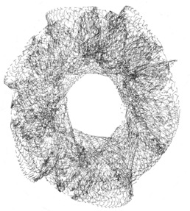
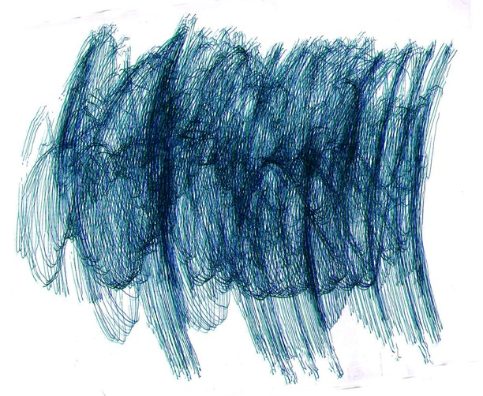
Figs 35 & 36 Turntable machines random programming; one and two colour versions
Fig 37 Turntable machine with linear table instead of circular

SINEWAVE MACHINE

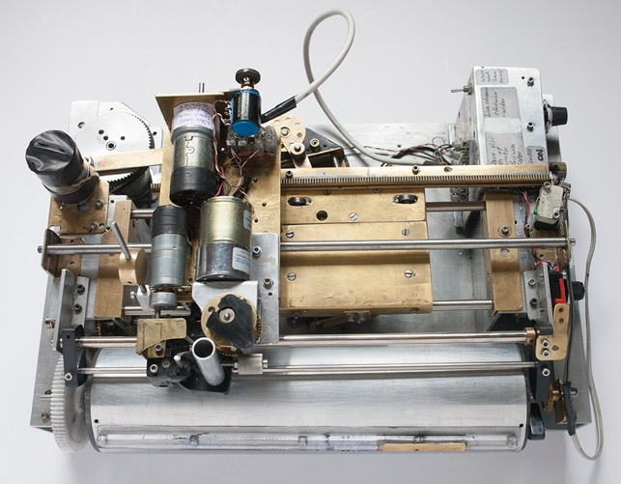
A number of these machines have been made, the latest able to be programmed to create random outputs. The controls in this machine can be interactive; the settings changed in real time as the drawing proceeds Fig 39. There are two settings, pen lift and wave deform which help in investigating randomness.
Fig 38 Sinewave machine, interactive controls

The Sinewave machine Fig 38 is designed to draw sine waves with variations in wave amplitude, line spacing, speed of wave growth, pen lift and a wave deform feature to mimic wave breaks.

Generally, it produces drawings with limited random input, but it is possible to programme it to go towards chaos by allowing the pen lift and wave break features to be far out of sync with the wave form Fig 40.

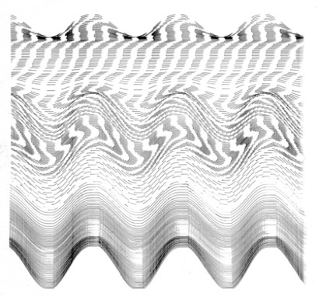
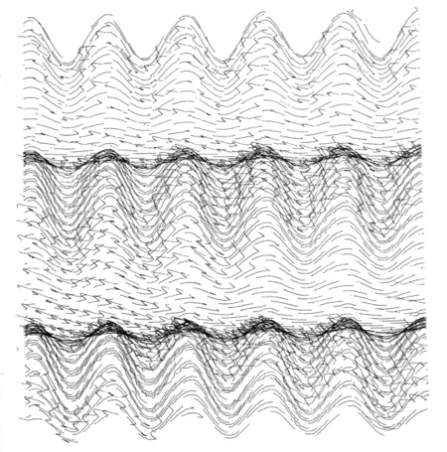
Fig 39 Sine wave with pen lift and interactive changes and limited random input.
Fig 40 Sine wave drawing with full random input
In the above graphic drawings a variety of images from the four machines show different approaches with random inputs moving close to chaos. The final set of images are made with light pens moved by the X:Y plotter machines. They have photographic qualities; some have a three-dimensional appearance. The colour is overlaid during the drawing process which serves to display random characteristics.

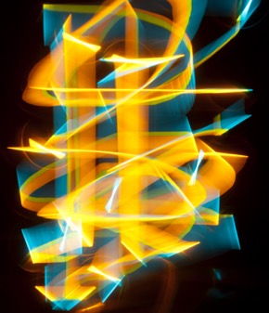
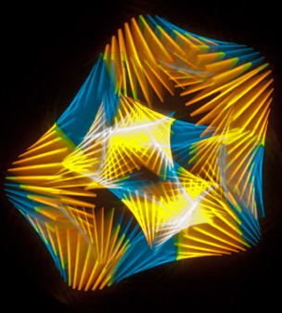
Whilst most light images are aesthetic in character, the ones selected from a large number, contain a greater proportion of random input. They are shown in pairs, one aesthetic and the other with more random character.
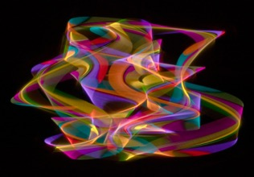
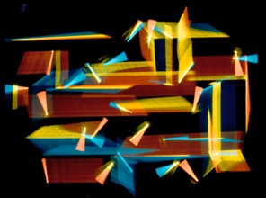
Fig 41 Formal aesthetic programming Fig 42 More random input
Fig 43 Formal aesthetic programming Fig 44 More random input

The Programmers
Two programmers have been used to create the drawings shown. As shown in Figs 41-44 the programming has a great effect on the output. The first shown below is a sequential timer with multiple times and outlets allowing a very large number of combinations. Any randomness created must depend on the relative sequence and timings combined with the unpredictable aspects of the D.C. motors and the linkages. This has been found to generate many drawings with sufficient randomness veering towards chaos for purposes of the study.

However, it was felt that a programmer with fully random outputs could extend the scope and the Randomiser was designed to mimic the throw of a dice. (Homage to Kenneth Martin ²⁰ once more). The six outlets allowed X,Y and Pen together with the permutations X/Y, X/Pen and Y/Pen. In addition, an asymmetric Forward/Reverse control unit extends the range even further.

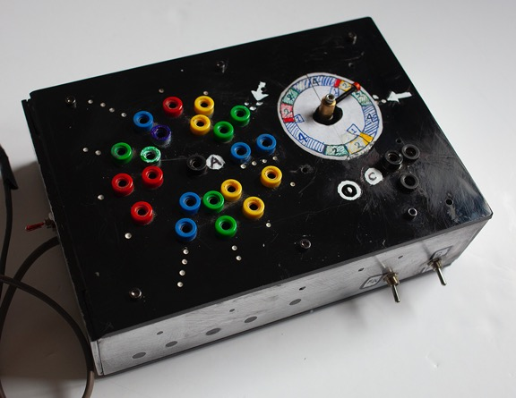
This significant progress, gives a better randomness output than all other previous programmers. The results in Figs 29-32 show this. They represent the achievement of line simplicity coupled with a wholly unpredictable drawing.
Fig 45 Sequential programmer 5 with multiple varied timed outlets
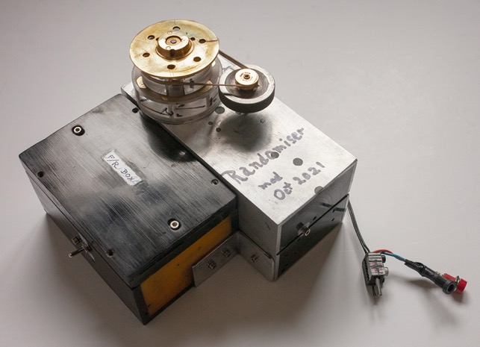
Chaotic images are possible up to and beyond the point where fine judgement is needed to decide whether the images show any coherence. This then leads to the possibility of investigating subjective responses. A paper doing this is in preparation cataloging several artist's reactions to a given set of drawings like those mentioned above.
Fig 46 Randomiser timer with added Forward /Reverse unit

Develop
With any form of machine-made art objects there is likely to be many potential images produced. Developing involves many test images and many modifications to the machines until the results comply with the initial notion of intent. Most modifications are the result of simplification. The first machines tend to be more complex than necessary. The programmable machines chosen for this study had sufficient programming flexibility to apply maximum randomness to the drawings to the point where they were almost chaotic which of course is a subjective judgement.

The journey to this point has been helped significantly by the introduction of the Randomiser programmer descried above. Over some years they had been built and rebuilt to reach this point, always aiming to have flexibility but only recently has the emphasis been directed towards exploring randomness and chaos. Previously the intent was to make drawings with aesthetic qualities and any randomness, whilst an essential part of the process, was secondary.

Selection
Whilst the generative art methodology produces so many variations, the process itself is often relatively simple. The historical experience, described in the early part of the paper, inevitably has a great bearing on the selection process. Given this, coupled with 50 years’ experience in making machine drawings, the successful ones stand out quickly from around 10 to 15 versions made on each run. They will be sub-consciously compared with hundreds of previous drawings both from similar and different machines. The process of selection is subject to what the author terms a 'fuzzy notion of intent' which begins to form prior to the moment when the construction begins. Furthermore, we come full circle to the early absorption of influences acquired by years of looking at other artist's work.

Display
The principal mode of display has been for the drawings to be made into digital prints. Most of them will have been subject to much afterwork from scanning to work in Adobe Photoshop. The maximum size has tended to be A2 governed by the costs, but the author feels that they could work better at a much larger size.

With the graphic drawings, the later addition of colour has been important in making pictures to exhibit. The colour choice is intuitive, aiming to realise the potential seen in the original drawing, being used extensively in the author's work.

Conclusions
Random input has dominated the route to the destination, hopefully enhanced by the places visited during the journey. With an historical overview of many images seen, two strands emerge. Early images exploited four main approaches with where the images were selected for expressive qualities. These are: -

- Lissajous figures ( Linkogram, Meccanograph and Hommage to Henry)
Interesting secondary patterns develop due to phase changes in the X:Y axes. The emergent random effects influenced other departures.

- Sine waves
Variable amplitude and line to line spacing, pen lift and wave form interruption generate random effects augmenting the deterministic basic sine wave.

- X:Y plotters (Various versions, flat bed and drum)
Sun and planet drives, with added pen lift and rotation, controlled by programmers, allows complex lines and increased random input to reach the point of chaos. This has become the main area of research, providing maximum flexibility using both light and graphic pens.

- Turntable machines (Various versions, latest design for random input)
Circular images extend the range of the drawing's characteristics.

Work from the above machines, has led to the current preoccupation with randomness, chaos, and subjectivity, touching upon aspects of psychology, perception and philosophy, seeking insights into how art works.

It is possible to argue that current analogue machines and programmers justify the choice of analogue, offering significantly different results from digital procedures. Random characteristics, progressing towards chaos, now permit investigation of 'persistence of coherence' in graphic images. This also has perception implications permitting assessment of subjective preferences.

A recurring thought has influenced process and motivation. Machine drawings are 'unimaginable' in proprioception terms. The expression "I would not have thought of drawing like that" may be applied. Unpredictability may be seen as the mainspring of generative art.

Final images are selected for expressive qualities where the random input is secondary Fig 47; others near chaotic images with pen lift disrupting the lines reaching the limits of coherence Fig 48. Others show the difference between curated drawings, chosen to examine the contribution of added colour, aiming to highlight the drawing's potential contrasted with drawings left in line form.

It is fitting to end on drawings themselves, where textual arguments may be weighed alongside each viewer's reactions. They might arrive at a valuation of analogue work in the greater context of generative art. It is hoped that the stopping points along the journey will demonstrate a consistency of creative thinking over seven decades and that the current position is sufficiently in accord with prevalent thinking about the role of randomness and chaos in generative art.

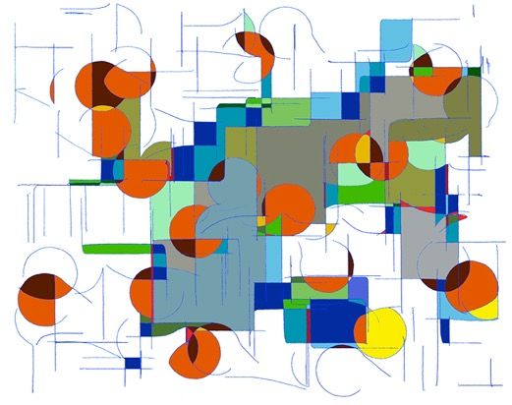
Fig 47 NSEW drawing, minimum randomness possible homage to Joan Miro ¹¹
Fig 48 NSEW drawing with maximum random input approaching a non-coherent state.
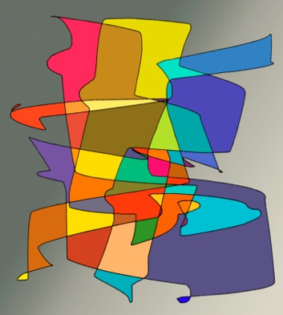
Fig 49 NSEW drawing with minimum random input and added colour.
Fig 50 'Edge of Chaos', drawing with maximum random, chosen with Paul Klee ⁶ in mind.

Bibliography

1, Perez, Carlos E. (2017),’Deconstructing Randomness as Chaos and Entanglement in Disguise’, Intuition Magazine.

2. Lostritto, Carl (2019 ), ‘The Value of Randomness in Art and Design’, https://www.fastcompany.com/3052333/the-value-of-randomness-in-art-and-design

3. Bennett, Deborah,(2011), ‘Defining Randomness, Philosophy of Statistics Volume 7 in Handbook of the Philosophy of Science,2011, Pages 633-639, https://www.sciencedirect.com/science/article/pii/B9780444518620500204#!

4. Jones, Christopher P (2019), ‘Subjectivity and Objectivity in Art, Understanding the gap between personal and public responses to art’, Essential Styles in Western Art History.
https://christopherjones.medium.com/subjectivity-and-ojjectivity-in-art-cc41d55c76a5

5. Grilo, Maria,(2021), ‘The subjective experience of enjoying art, Design, https://www.imaginarycloud.com/blog/the-subjective-experience-of-enjoying-art/

6. Klee, Paul (1979) 'On Modern Art', Faber and Faber Ltd. London & Boston, see also Bauhaus.

7. Tait, Jack (2013)'Art by Machine, Taitographs, Programmable Analogue Drawing Machines’, ‘Bronydd Press, Hay on Wye, Wales, 2013

8. Bauhaus, (1968) '50 years bauhaus', Exhibition catalogue, Royal Academy of Arts, London.

9. Guildford School of Art, (1955-58) Principal Dudley Holland, Stoke Park, Guildford, Surrey

10. Kandinsky, (2006) 'The Path to Abstraction' Exhibition catalogue, Tate Modern, Tate Publishing, London.

11. Miro, joan, (2011) ‘The ladder of Escape’ Tate Modern, London

12. Cybernetic Serendipity, (1968), ‘Cybernetic Serendipity’ curated by Jasia Rheichart, ICA, London.

13. Derby College of Art, (1964) Principal Tom Wrigley, Green Lane, Derby.

14. Kodak Color Scholarships (1959-1965), Kodak Ltd., London and Eastman Kodak Company, Rochester, USA.

15. Manchester Polytechnic (1965) Principal John Holden, All Saints, Manchester.

16. Tait, Jack (1977), ‘Beyond Photography’, Focal Press, London.

17. Royal College of Art (1980) Principal Robin Darwin, Kensington, London.

18. Gwent College of Higher Education, (1980) Principal John Wright, Church Street, Newport, S.Wales

19. Base 8 programming language (1969) Vintage language no longer used.

20. Martin, Kenneth (1975) ‘Kenneth Martin’, Tate Gallery publication, London.

21. Manchester MIRIAD, (2009-11), ‘Post graduate department, Manchester Metropolitan University, All Saints, Manchester.

22. Tait, Jack (2011),’Programmable Analogue Drawing Machines’, Ph.D Manchester MIRIAD

23. Science Museum, (2012), ‘Ph.D Machines, programmers, pictures and movies acquired’ Maths Department, Kensington, London.

24. O’Hanrahan, Elaine (2005) ‘Drawing Machines: The Machine Produced Drawings of Dr. D.P. Henry in Relation to Conceptual and Technological Developments in Machine-Generated Art’, UK 1960-68', John Moores University, Liverpool.

25. Sperry bombsight computer, (1943-45), ‘Mark XIV Computing bombsight’ fitted to R. A. F. Lancaster bombers in the latter half of WW2.

Jack Tait Abergavenny, Wales, UK 2022

